Investigating why large ships float
and keys sink - Conclusion

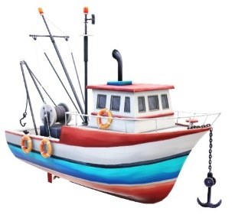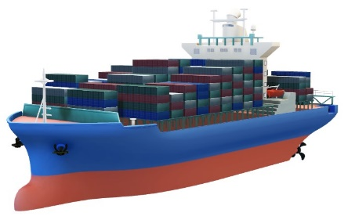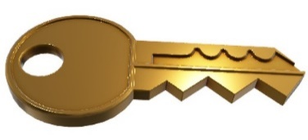

- Experiment 1: Water Displacement
- Experiment 2: Density of Objects - Will it Sink or Float?
- Experiment 3: Volume & Weight – Which will Sink or Float?
- Experiment 4: Surface Area & Buoyancy

After completing the experiments involving water displacement, density of objects, volume and weight, as well as surface area and buoyancy, can you explain why a heavy large ship can float and a small key would sink in the ocean?
Conclusion

